

**MWC UI Modernization**

Use Case: B04-UCS-MD-Process Work Sharing Weekly Certification Request

**Document Revision History**

|  |  |  |
| --- | --- | --- |
| **Release Date** | **Owner** | **Summary of Changes** |
| 08/23/2016 | M Brenner | Product use case baseline |
| 09/08/2016 | J Fett | Review of product use case baseline |
| 09/20/2016 | D Price | Corrections to use case based on B03 – Set-up or Modify Work Sharing and drafted for B04 fit gap sessions |
|  |  |  |
|  |  |  |
|  |  |  |

**Approvals**

|  |  |  |
| --- | --- | --- |
| **Name** | **Signature** | **Date** |
| <first initial and last name> | <full name> | <mm/dd/yyyy> |

table of Contents

Use Case: B04-USC-Process Work Sharing Weekly Certification Request i

1 BRIEF DESCRIPTION 1

2 ACTORS 1

3 PRE-CONDITIONS 1

4 POST-CONDITIONS 1

5 MAIN FLOW 3

5.1 Alternate Flow – Alternate Flow One: Claimant Submits Work Sharing Weekly Certification 3

5.2 Alternate Flow – Alternate Flow Two: Employer Resolves Work Sharing Plan Claim Discrepancy 4

6 BUSINESS LOGIC – MAIN FLOW 1

6.1 Alternate Flow – Alternate Flow One: Claimant Submits Work Sharing Weekly Certification 3

6.2 Alternate Flow – Alternate Flow Two: Employer Resolves Work Sharing Plan Claim Discrepancy 6

7 SCREEN FLOW 8

8 SCREEN LAYOUTS 9

8.1 Screen 1 – Work Sharing Plan 10

8.2 Screen 2 – File Work Sharing Plan Claim - Employer 21

8.3 Screen 3 – File Work Sharing Plan Weekly Claim - Employer 26

8.4 Screen 4 – Confirmation 33

8.5 Screen 5 – Claimant Work Sharing Hours 34

8.6 Screen 6 – Review and Submit - Claimant 39

8.7 Screen 7 – Resolve Work Sharing Plan Claim Discrepancy 45

8.8 Screen 8 – Review Work Sharing Plan Discrepancy Workflow 52

8.9 Screen 9 – Process Weekly Certification 60

9 INTEGRATION POINTS 61

10 INTERFACES 61

11 REPORTS 61

12 COMMUNICATION 61

13 WORKFLOW 62

14 ASSISTIVE CONTENT 62

15 OTHER NOTES 62

16 REFERENCED REQUIRMENTS 63

Use Case Specification:   
B04-UCS-MD-Process Work Sharing Weekly Certification Request

# BRIEF DESCRIPTION

The B04-UCS-MD-Process Work Sharing Weekly Certification Request use case outlines the process for when an employer, who has set up a Work Sharing Plan, requests to file a weekly claim for benefits. This is a process for the employer to submit the weekly claim and the claimant(s) to verify the claim.

# ACTORS

This use case interacts with the following actors:

* Agency staff
* Employer
* Claimant
* System

# PRE-CONDITIONS

Any or all of the following conditions must be met in order to trigger this use case:

* The employer is a registered user
* The employer has created a Work Sharing plan which has been approved for a set of employees
* The employer has logged into the system and wants to file a continued claim for all Work Sharing participants and the claimant
* The claimant has been successfully authenticated
* The claimant has an active claim
* The Determine Eligible Function use case has determined that the claimant is eligible to request benefits and the Work Sharing continued claim certification link is made available to the claimant
* The Determine Eligible Function use case has determined the week(s) available for weekly certification
* The claimant has selected a Work Sharing continued claim certification

# POST-CONDITIONS

This use case provides the following conditions:

* The employer has submitted a weekly claim for a specific Work Sharing plan
* The claimant has verified the weekly claim, submitted by the employer, for a specific weekly certification week
* If applicable, a workflow has been created for staff to correct discrepancies between information entered by the employer and the claimant for the weekly certification
* Payment has been processed or the claimant has been ineligible for the weekly claim

# MAIN FLOW

The main flow describes a scenario where an employer certifies a week claim.

1. The system displays the *Work Sharing Plan screen* and displays all Work Sharing Plans the employer has set-up.
2. If the employer selects a Work Sharing Plan and selects ‘Add, ‘Edit’, ‘View’, or ‘Delete’ a work sharing plan:
   1. The system proceeds to the Setup or Modify Work Sharing Plan use case.
   2. The system proceeds to Main Flow step 6.
3. When the employer selects ‘Submit Claim Week [mm/dd/yyyy]’ for a Work Sharing Plan:
   1. The system navigates to the *File Work Sharing Plan Claim screen*.
      1. The employer enters weekly claim information for the claimants and selects ‘Next’.
      2. The system stores the employer’s answers.
   2. The system navigates to the *File Work Sharing Plan Claim Confirmation screen* and displays previous weeks available for claim submission*.*
      1. The employer selects ‘Select Another Plan’ or ‘Finish’ and the system navigates back to the *Work Sharing Plan screen*.
         1. If the employer selects ‘Select Another Plan’ proceed to Main Flow step 1.
4. The system will display the ‘Edit Claim’ link for the employer after a claim week has been submitted, until all claimants have submitted the weekly certification.
   1. After all claimants on the Work Sharing Plan have submitted their weekly certification, the system will no longer display the ‘Edit Claim’ hyperlink.
5. The system allows all claimants on the Work Sharing Plan to submit a weekly certification after the employer has submitted the weekly claim.
   1. The system proceeds to Alternate Flow One: Claimant Submits Work Sharing Weekly Certification.
6. The Main Flow ends.

## Alternate Flow – Alternate Flow One: Claimant Submits Work Sharing Weekly Certification

1. From Main Flow step 4.1
2. The system retrieves the week(s) available for weekly certification from the Determine Eligible Function use case.
3. The system displays the *Process Weekly Certification screen*.
4. The system displays the *Claimant Work Sharing Hours screen*.
5. The user answers the initial questions and selects ‘Next’.
6. The system evaluates all the user’s answers and proceeds to the appropriate use case, per the business rules.
7. The system displays the *Review and Submit screen* where the user can review and select to ‘Edit’ answers.
8. User selects ‘Next’ after checking the box acknowledging that all information is true and correct.
   1. If the information the claimant entered does not match what the employer entered, the system will hold the claimant’s payment.
   2. The system will notify the employer that there is a discrepancy between what they entered and what the claimant entered.
      1. The system proceeds to Alternate Flow Two: Employer Resolves Work Sharing Plan Claim Discrepancy.
9. The system updates each potential issue record with the current date/time stamp, and posts all issues through the Create New Issue use case.
10. The system calls the Process and Issue Weekly Certification Payment use case in order to calculate the authorized amount.
11. The system displays the *Confirmation screen* including:
    1. Weekly Certification Status
    2. Remaining Weekly Certification Weeks Available
12. User selects ‘Finish’ and the system returns to the Claimant Home Page.
13. Proceed back to Main Flow step 5.
14. This Alternate Flow ends.

## Alternate Flow – Alternate Flow Two: Employer Resolves Work Sharing Plan Claim Discrepancy

1. From Alternate Flow One step 8.2.1.
2. The system notifies the employer that the claimant entered weekly certification information different than what they provided for the Work Sharing Plan.
3. The employer selects ‘Resolve Discrepancy’ on the *Work Sharing Plan screen*.
   1. The system navigates to the *Resolve Work Sharing Plan Claim Discrepancy screen*.
4. If the employer agrees with the information the claimant entered, the employer updates their information to match the claimant.
   1. The employer resubmits the weekly claim.
   2. The system releases the hold on the claimant payment.
   3. Proceed to step 6 of this Alternate Flow.
5. If the employer does not agree with the information the claimant entered, the employer does not make any changes to their information.
   1. The employer resubmits the claim.
   2. The system creates a Resolve Work Sharing Plan Discrepancy workflow for agency staff.
      1. Agency staff review the workflow item and follow-up with both the employer and the claimant to resolve the discrepancy.
6. Proceed back to Alternate Flow step 9.
7. This Alternate Flow ends.

# BUSINESS LOGIC – MAIN FLOW

The business rules are listed below.

| **BR** | **DESCRIPTION** | **FIT/GAP** | **NOTES** |
| --- | --- | --- | --- |
| 1.0 | The system will display the ‘Submit Claim Week [mm/dd/yyyy]’ link for a Work Sharing Plan if the following conditions are met: |  |  |
| 1.1 | If the Work Sharing Plan status equals ‘APRV’ on the SGT_STC_PLAN table, **AND** |  |  |
| 1.2 | There is no record on the SGT_REQUEST_WEEK_STC_PLAN for the EMPLOYER_ACCOUNT_ID, STC_PLAN_ID, and REQUEST_WEEK_DATE, **OR** |  |  |
| 1.2.1 | There is a record on the SGT_REQUEST_WEEK_STC_PLAN for the EMPLOYER_ACCOUNT_ID, STC_PLAN_ID, and REQUEST_WEEK_DATE, but the REQUEST_STATUS_VALUE does not equal ‘CLMD’. |  |  |
| 2.0 | The system will require the employer to submit the oldest week available. |  |  |
| 2.1 | The system will determine weeks available using the Work Sharing Plan PLAN_BEGIN_DATE and PLAN_END_DATE on the SGT_STC_PLAN table. |  |  |
| 3.0 | The system will display all employees included in the Work Sharing Plan. |  |  |
| 3.1 | All SSN’s on the SGT_STC_PLAN_EMPLOYEE table associated with the STC_PLAN_ID. |  |  |
| 4.0 | The system will pre-populate the employees’ ‘Available Hours’ from the REDUCED_TO_HOURS field on the SGT_STC_PLAN_EMPLOYEE table. |  |  |
| 4.1 | The system will display this field as editable and allow the employer to update. |  |  |
| 5.0 | The system will require the employer to enter ‘Actual Hours Worked’, ‘Leave Hours’, ‘Gross Earnings’, and, if applicable, select a ‘Reason’ for every employee on the Work Sharing Plan. |  |  |
| 5.1 | The system will require the employer to select a ‘Reason’ if an employee’s total hours (‘Actual Hours Worked’ plus ‘Leave Hours’) differ from the ‘Available Hours’ for the claimant on the Work Sharing Plan. |  |  |
| 6.0 | The system will update the following upon ‘Submit’: |  |  |
| 6.1 | REQUEST_STATUS_VALUE on the SGT_REQUEST_WEEK_STC_PLAN table to ‘CLMD’. |  |  |
| 6.2 | EMPLOYER_OFFERED_HOURS on the SGT_REQUEST_WEEK_STC_PLAN_EMPLOYEE table |  |  |
| 6.3 | EMPLOYER_ACTUAL_HOURS on the SGT_REQUEST_WEEK_STC_PLAN_EMPLOYEE table |  |  |
| 6.4 | EMPLOYER_LEAVE_HOURS on the SGT_REQUEST_WEEK_STC_PLAN_EMPLOYEE table |  |  |
| 6.5 | EMPLOYER_GROSS_EARN_AMT on the SGT_REQUEST_WEEK_STC_PLAN_EMPLOYEE table |  |  |
| 6.6 | EMPLOYER_REASON_VALUE on the SGT_REQUEST_WEEK_STC_PLAN_EMPLOYEE table |  |  |
| 7.0 | The system will store the employer’s weekly certification information as a PDF. |  |  |
| 7.1 | The system will make the submitted weekly certification PDF available for the employer to view through Documents. |  |  |
| 8.0 | The system will display the File Work Sharing Plan Claim Confirmation screen. |  |  |
| 9.0 | The system will display any other available weeks the employer has to claim. |  |  |
| 9.1 | The system will determine remaining weeks available using the Work Sharing Plan PLAN_BEGIN_DATE and PLAN_END_DATE on the SGT_STC_PLAN table. |  |  |
| 10.0 | The system will only display the ‘Edit Claim’ link for the employer if the following conditions are met: |  |  |
| 10.1 | There is a record on the SGT_REQUEST_WEEK_STC_PLAN table for the EMPLOYER_ACCOUNT_ID, STC_PLAN_ID, and REQUEST_WEEK_DATE, with a REQUEST_STATUS_VALUE equal to ‘CLMD’, **AND** |  |  |
| 10.2 | There is a record on the SGT_REQUEST_WEEK_STC_PLAN_EMPLOYEE table for the STC_PLAN_EMPLOYEE_ID, but no corresponding claimant data, **AND** |  |  |
| 10.3 | There is no record on the SGT_REQUEST_WEEK_CTRL table for the corresponding CLAIMANT_ID. |  |  |
| 11.0 | The system will display the *File Work Sharing Plan Claim screen* and allow the employer to edit each claimant’s information until the claimant has submitted their weekly certification.  (See Alternate Flow One: Claimant Submits Work Sharing Weekly Certification) |  |  |
| 11.1 | The system will display all information as editable. |  |  |
| 11.2 | The system will display an error message if the employer edits a claimant record and they have already submitted their weekly claim. |  |  |
| 11.2.1 | There is a record on the SGT_REQUEST_WEEK_CTRL table for the corresponding CLAIMANT_ID. |  |  |

## Alternate Flow – Alternate Flow One: Claimant Submits Work Sharing Weekly Certification

| **BR** | **DESCRIPTION** | **FIT/GAP** | **NOTES** |
| --- | --- | --- | --- |
| 1.0 | The system will determine a claimant is a participant of a Work Sharing Plan if the following conditions are true: |  |  |
| 1.1 | The Work Sharing Plan has been approved, **AND** |  |  |
| 1.1.1 | STC_PLAN_ID on the SGT_STC_PLAN table has a STATUS_VALUE of ‘APRV’ |  |  |
| 1.2 | The claimant’s SSN is associated with a Work Sharing Plan, **AND** |  |  |
| 1.2.1 | SSN on the SGT_STC_PLAN_EMPLOYEE table associated with STC_PLAN_ID in ‘APRV’ status on the SGT_STC_PLAN table. |  |  |
| 1.3 | The claimant has an active claim, **AND** |  |  |
| 1.3.1 | CLAIM_ID on the SGT_CLAIM table |  |  |
| 1.4 | The weekly certification date is between the PLAN_BEGIN_DATE and PLAN_END_DATE on the SGT_STC_PLAN table |  |  |
| 2.0 | The system will determine a week is available for the claimant to certify if the following conditions are true: |  |  |
| 2.1 | There is a record on the SGT_REQUEST_WEEK_STC_PLAN table for the EMPLOYER_ACCOUNT_ID, STC_PLAN_ID, and REQUEST_WEEK_DATE, with a REQUEST_STATUS_VALUE equal to ‘CLMD’, **AND** |  |  |
| 2.2 | The Determine Eligible Function use case has provided the week(s) this use case will present to the claimant. |  |  |
| 2.3 | Claimants on a Work Sharing Plan must satisfy the Waiting Week.  (See Process and Issue Weekly Certification Payment use case) |  |  |
| 3.0 | The system calculates and displays the Sunday beginning date of each week in the weekly certification period, and the Saturday end date of each week of the weekly certification period. |  |  |
| 3.1 | Begin Date is the Sunday date of each week the user begins the weekly certification. |  |  |
| 3.2 | End Date is the Saturday date of the week the user completes the weekly certification. |  |  |
| 4.0 | If the user chooses to exit before completing the weekly certification, any data entered will be saved. |  |  |
| 4.1 | The system will set the STATUS_CODE_VALUE to ‘PEND’ (pending) on the SGT_REQUEST_WEEK_CTRL table. |  |  |
| 5.0 | The system will allow the claimant to request each weekly certification week, one time. |  |  |
| 6.0 | The system will track and store the method of completing a weekly certification. |  |  |
| 6.1 | AWEB – claimant self-service web |  |  |
| 6.2 | SWEB – staff assisted web (staff has logged into the WEB as a user) |  |  |
| 6.3 | AIVR – claimant self-service IVR  (If functionality developed by ‘STATE’) |  |  |
| 6.4 | SIVR – staff assisted IVR  (If functionality developed by ‘STATE’) |  |  |
| 7.0 | The weekly certification week must match the program type and claim ID. |  |  |
| 8.0 | The system will record when the user begins the weekly certification process. |  |  |
| 9.0 | The system will record when the user completes the weekly certification process. |  |  |
| 10.0 | The system will proceed as follows, based on the user’s responses to the initial questions: |  |  |
| 11.0 | If user selects ‘Yes’ to the question ‘During the week listed above did you quit or were you discharged from a job?’ the system will proceed to the Collect Employment Information use case. |  |  |
| 11.1 | If user selects ‘No’ to the question ‘During the week listed above did you quit or were you discharged from a job?’ the system will proceed to the next step. |  |  |
| 12.0 | The user enters ‘Actual Hours Worked’, ‘Leave Hours’, and ‘Gross Earnings’. |  |  |
| 13.0 | The system will display a summary of the user’s weekly certification, including all information and fact-finding questionnaires, on individual tabs, entered by the user for the weekly certification. |  |  |
| 14.0 | If the claimant modifies initial questions, the system will navigate back through the main flow. |  |  |
| 14.1 | If the claimant modifies any other information, that is not the initial questions, the system will call the specific use case for the modification of that data from the *Review and Submit screen.* |  |  |
| 15.0 | The system will store the weekly certification information as a PDF. |  |  |
| 15.1 | The system will make the submitted weekly certification PDF available for the user to view through Correspondence. |  |  |
| 16.0 | The system will do the following prior to displaying the *Confirmation* screen: |  |  |
| 16.1 | Store the claimant’s ‘Actual Hours Worked’, ‘Leave Hours’, and ‘Gross Earnings’. |  |  |
| 16.1.1 | CLAIMANT_ACTUAL_HOURS on the SGT_REQUEST_WEEK_STC_PLAN_EMPLOYE table. |  |  |
| 16.1.2 | CLAIMANT_LEAVE_HOURS on the SGT_REQUEST_WEEK_STC_PLAN_EMPLOYE table. |  |  |
| 16.1.3 | CLAIMANT_GROSS_EARN_AMT on the SGT_REQUEST_WEEK_STC_PLAN_EMPLOYE table. |  |  |
| 16.2 | Write a record to the SGT_REQUEST_WEEK_CTRL table and set the WORKSHARE_IND to ‘Y’. |  |  |
| 16.3 | Compare the claimant entered information (CLAIMANT_ACTUAL_HOURS, CLAIMANT_LEAVE_HOURS, and CLAIMANT_GROSS_EARN_AMT) to the employer entered information (EMPLOYER_ACTUAL_HOURS, EMPLOYER_LEAVE_HOURS, and EMPLOYER_GROSS_EARN_AMT) on the SGT_REQUEST_WEEK_STC_PLAN_EMPLOYEE table. |  |  |
| 16.3.1 | If the any of the claimant entered information does not match what the employer entered, the system will: |  |  |
| 16.3.1.1 | Set the STATUS_CODE_VALUE to ‘DSCR’ (discrepancy) on the SGT_REQUEST_WEEK_CTRL table and hold the claimant’s payment. |  |  |
| 16.3.1.2 | Send an alert to the employer in the employer portal, notifying them of the discrepancy.  (See Alternate Flow Two: Employer Resolves Work Sharing Plan Claim Discrepancy) |  |  |
| 16.3.2 | If the claimant entered information does match what the employer entered, the system will: |  |  |
| 16.3.2.1 | Indicate the week(s) that will be routed to Process and Issue Weekly Certification Payment use case to process the payment. |  |  |
| 16.3.2.2 | Set the STATUS_CODE_VALUE to ‘PROC’ (processed) on the SGT_REQUEST_WEEK_CTRL table, if the weekly certification is submitted with no other issues. |  |  |

## Alternate Flow – Alternate Flow Two: Employer Resolves Work Sharing Plan Claim Discrepancy

| **BR** | **DESCRIPTION** | **FIT/GAP** | **NOTES** |
| --- | --- | --- | --- |
| 1.0 | The employer receives notification that the claimant submitted their Work Sharing Plan weekly certification with different information than what the employer entered. |  |  |
| 2.0 | The system will display the ‘Resolve Discrepancy’ link for the Work Sharing Plan on the *Work Sharing Plan screen*. |  |  |
| 3.0 | The system will navigate to the *Resolve Work Sharing Plan Claim Discrepancy screen* and for only claimant(s) with a discrepancy, display the following information: |  |  |
| 3.1 | Previously entered claimant information, in read only: |  |  |
| 3.1.1 | CLAIMANT_ACTUAL_HOURS from the SGT_REQUEST_WEEK_STC_PLAN_EMPLOYEE table |  |  |
| 3.1.2 | CLAIMANT_LEAVE_HOURS from the SGT_REQUEST_WEEK_STC_PLAN_EMPLOYEE table |  |  |
| 3.1.3 | CLAIMANT_GROSS_EARN_AMT from the SGT_REQUEST_WEEK_STC_PLAN_EMPLOYEE table |  |  |
| 3.2 | Previously entered employer information, editable: |  |  |
| 3.2.1 | EMPLOYER_ACTUAL_HOURS from the SGT_REQUEST_WEEK_STC_PLAN_EMPLOYEE table |  |  |
| 3.2.2 | EMPLOYER_LEAVE_HOURS from the SGT_REQUEST_WEEK_STC_PLAN_EMPLOYEE table |  |  |
| 3.2.3 | EMPLOYER_GROSS_EARN_AMT from the SGT_REQUEST_WEEK_STC_PLAN_EMPLOYEE table |  |  |
| 3.2.4 | EMPLOYER_REASON_VALUE from the SGT_REQUEST_WEEK_STC_PLAN_EMPLOYEE table |  |  |
| 4.0 | If the employer agrees with the claimant entered information, the employer will update the information to match the claimant and select ‘Submit’. |  |  |
| 4.1 | Upon ‘Submit’ the system will: |  |  |
| 4.1.1 | Indicate the week(s) that will be routed to Process and Issue Weekly Certification Payment use case to process the payment. |  |  |
| 4.1.2 | Update the STATUS_CODE_VALUE to ‘PROC’ (processed) on the SGT_REQUEST_WEEK_CTRL table. |  |  |
| 5.0 | If the employer does not agree with the claimant entered information, the employer will not make any updates and select ‘Submit’. |  |  |
| 5.1 | Upon ‘Submit’ the system will: |  |  |
| 5.2 | Proceed to the Create New Issue use case and create Issue Type ‘Work Sharing’ (WKSH) and Issue Subtype ‘Working Sharing Plan Hours’ (WWPH). |  |  |
| 5.3 | Create a ‘Review Work Sharing Plan Discrepancy’ workflow item for agency staff. |  |  |

# SCREEN FLOW

The following diagram illustrates the screen flows for this use case:



# SCREEN LAYOUTS

Summary – List of Screens

8.1 Screen 1 – Work Sharing Plan

8.2 Screen 2 – File Work Sharing Plan Claim - Employer

8.3 Screen 3 – File Work Sharing Plan Weekly Claim - Employer

8.4 Screen 4 – Confirmation

8.5 Screen 5 – Claimant Work Sharing Hours

8.6 Screen 6 – Review and Submit - Claimant

8.7 Screen 7 – Resolve Work Sharing Plan Claim Discrepancy

8.8 Screen 8 – Review Work Sharing Plan Discrepancy Workflow

8.9 Screen 9 – Process Weekly Certification

## Screen 1 – Work Sharing Plan

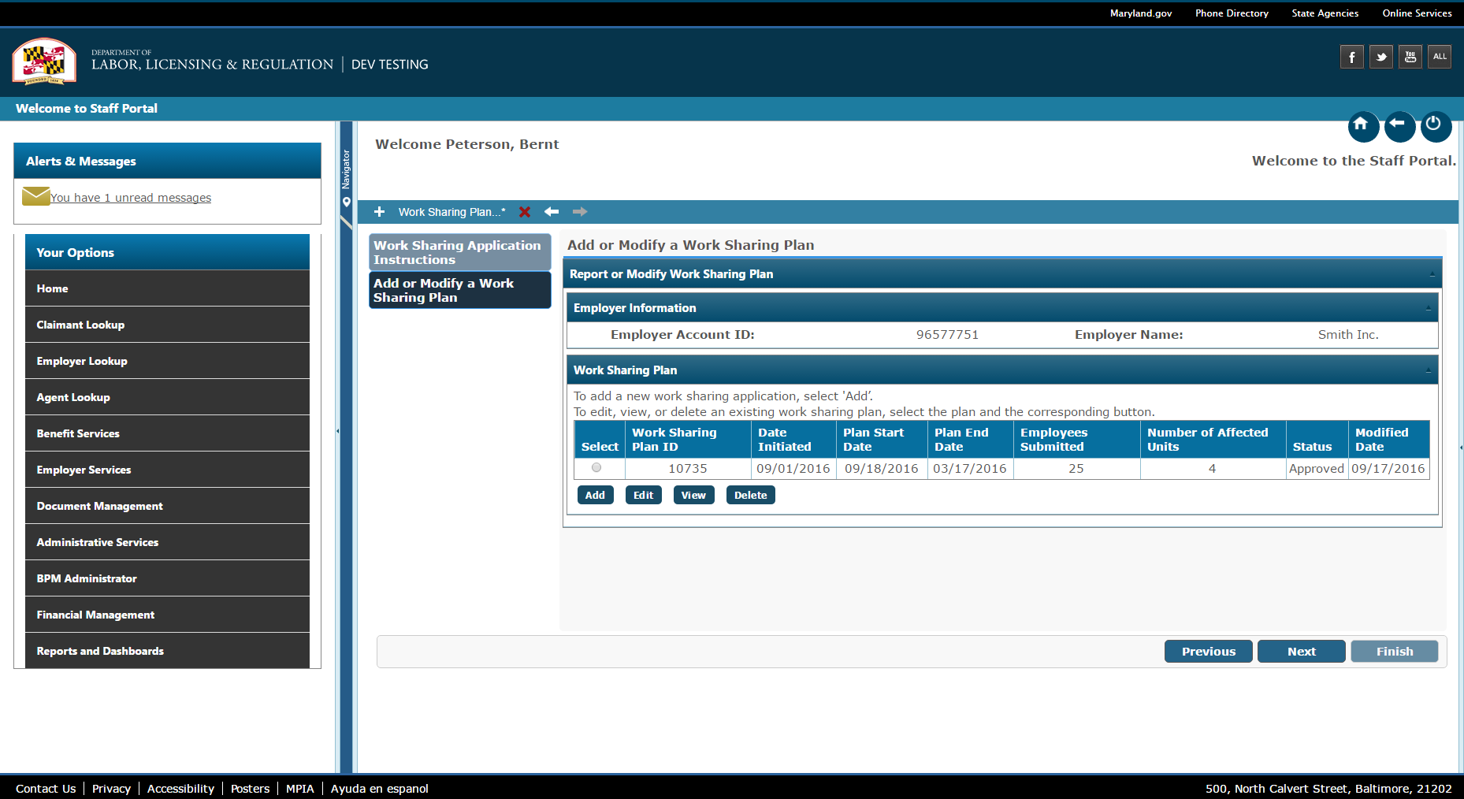This screen allows the employer to select a week to submit a claim.

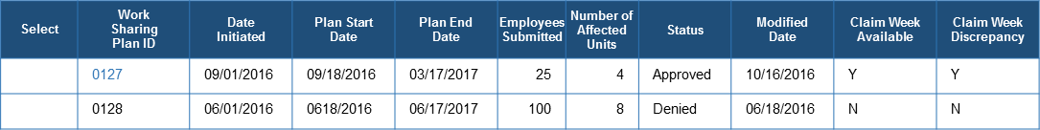

To add a new work sharing application, select 'Add’

To edit, view, or delete an existing work sharing plan, select the list and the corresponding button.

If you have a claim week(s) of Work Sharing hours to be reported. You must complete the information for all participating employees before the week is available to the employee for certification. Payments can only be made when all information is received.

Select the Work Sharing Plan ID hyperlink which indicates a claim week is available. If there are no available weeks to certify and you want to view previously submitted weekly certification select the Work Sharing Plan ID then select the ‘View’ button.

| **UI CONTROL** | **TYPE** | **DESCRIPTION** | **VALIDATION RULES** | **FIT/GAP** | **NOTES** |
| --- | --- | --- | --- | --- | --- |
| Application Wizard | Progress Bar | Step 1: Work Sharing Application Instructions  Step 2: Add or Modify a Work Sharing Plan  Step 3: Plan Contact Information  Step 4: Plan Details  Step 5: Plan Affected Units  Step 6: Plan Employee Details  Step 7: Supporting Documents  Step 8: Review and Submit  Step 9: Confirmation | Highlight Step 2 | Fit |  |
|  | Section Header | System displays: Employer Information |  | Gap |  |
| Employer Account ID | Label / Text | System displays the Employer Account ID label and the employer identification number as read only. |  | Gap |  |
| Employer Name | Label / Text | System displays the Employer Name label and the employer name as read only. |  | Gap |  |
|  | Section Header | System displays: Add or Modify a Work Sharing Plan |  | Gap |  |
| Instructional Text | Text | System displays ‘To add a new work sharing application, select 'Add’ |  | Gap |  |
| Instructional Text | Text | System displays ‘“To edit, view, or delete an existing work sharing plan, select the list and the corresponding button.’ |  | Gap | MD Action item to provide new language |
| Instructional Text | Text | System displays ‘If you have a claim week(s) of Work Sharing hours to be reported. You must complete the information for all participating employees before the week is available to the employee for certification. Payments can only be made when all information is received.’ |  | Gap |  |
| Instructional Text | Text | System displays ‘Select the Work Sharing Plan ID hyperlink which indicates a claim week is available. If there are no available weeks to certify and you want to view previously submitted weekly certification select the Work Sharing Plan ID, then select the ‘View’ button.’ |  | Gap | MD Action item to provide new language |
| Select | Label / Radio button | System displays the Select column header and radio button.  Allows the employer/staff to select the record | Not sortable | Gap |  |
| Work Sharing Plan ID | Column Header / Text / Hyperlink | System displays column header and ‘Work Sharing Plan ID as a hyperlink | By default, records will display by Work Sharing Plan ID in ascending order.  Displays Work Sharing Plan ID as a hyperlink if ‘Approved’ Work Sharing Plan has a week to claim  When selected, system navigates to the *File Work Sharing Plan Claim - Employer Screen* System  Read only  Sortable  Any column header when clicked, should sort that column in the ascending order first, if clicked again it should be sorted in descending order | Gap |  |
| Date Initiated | Label / Text | System displays the Date Initiated column header and the corresponding date the Work Sharing application was started. | Any column header when clicked, should sort that column in the ascending order first, if clicked again it should be sorted in the descending order. | Gap |  |
| Plan Start Date | Label / Text | System displays the Plan Start Date column header and the corresponding Plan Start Date. | Any column header when clicked, should sort that column in the ascending order first, if clicked again it should be sorted in the descending order. | Gap |  |
| Plan End Date | Label / Text | System displays the Plan End Date column header and the corresponding Plan End Date. | Any column header when clicked, should sort that column in the ascending order first, if clicked again it should be sorted in the descending order. | Gap |  |
| Employees Submitted | Label / Text / | System displays the number of employees submitted in the Work Sharing Plan |  | Gap |  |
| Number of Affected Units | Label / Text / | System displays the number of affected units submitted in the Work Sharing Plan |  | Gap |  |
| Status | Label / Text | System displays the Status column header and the corresponding Work Sharing status.  Status’ include:  Approved - Work Sharing Plan approved by staff  Incomplete - Work Sharing Plan application not completed by employer/staff  Pending - Work Sharing Plan submitted by employer and is being reviewed by staff  Withdrawn - Work Sharing Plan withdrawn by employer/staff  Expired - Work Sharing Plan has ended | Any column header when clicked, should sort that column in the ascending order first, if clicked again it should be sorted in the descending order. | Gap |  |
| Modified Date | Label / Text | System displays the Modified Date column header and the corresponding date when the Work Sharing Plan was last modified. | Any column header when clicked, should sort that column in the ascending order first, if clicked again it should be sorted in the descending order. | Gap |  |
| Claim Week Available | Column Header / Text | System displays column header and ‘Y” or ‘N’ | Displays ‘Y’ if Approved’ Work Sharing Plan has a week to claim for any claim week  Displays ‘N’ if Approved’ Work Sharing Plan does not have a week to claim for any claim week OR a Work Sharing Plan is not ‘Approved’  Read only  Sortable  Any column header when clicked, should sort that column in the ascending order first, if clicked again it should be sorted in descending order | Gap |  |
| ~~Edit Claim Week~~ | ~~Column Header / Text / Hyperlink~~ | ~~System displays column header and ‘[mm/dd/yyyy]’ as a hyperlink~~ | ~~Only displays if the employer has previously submitted a weekly claim~~  ~~When selected, system navigates to the~~ *~~Edit Work Sharing Plan Claim – Employer screen~~*  ~~Read only~~  ~~Sortable~~  ~~Any column header when clicked, should sort that column in the ascending order first, if clicked again it should be sorted in descending order~~ | ~~Gap~~ |  |
| Claim Week Discrepancy | Column Header / Text | System displays column header and ‘Y” or ‘N’ | Displays ‘Y’ if Approved’ Work Sharing Plan has a claim week discrepancy for any claim week  Displays ‘N’ if Approved’ Work Sharing Plan does not have any claim week discrepancy for any claim week OR a Work Sharing Plan is not ‘Approved’  Read only  Sortable  Any column header when clicked, should sort that column in the ascending order first, if clicked again it should be sorted in descending order | Gap |  |

**Command Keys**

| **UI CONTROL** | **TYPE** | **DESCRIPTION** | **VALIDATION RULES** | **FIT/GAP** | **NOTES** |
| --- | --- | --- | --- | --- | --- |
| Add | Button | The system navigates to the *Add or Modify Work Sharing Application* screen |  | Gap |  |
| Edit | Button | The system navigates to the *Work Sharing Contact Information* screen, for the selected Work Sharing Plan | If no Work Sharing Plan is selected, display error message:  ‘Please select a Work Sharing Plan.’ | Gap |  |
| View | Button | The system navigates to the *Work Sharing Contact Information* screen | If no Work Sharing Plan is selected, display error message:  ‘Please select a Work Sharing Plan.’ | Gap |  |
| Delete | Button | Once the Work Sharing Plan is deleted, the system navigates to the *Add or Modify Work Sharing Application* screen | If no Work Sharing Plan is selected, display error message:  ‘Please select a Work Sharing Plan.’  EMPLOYER  System must display the below message if the Work Sharing Plan has any status other than Incomplete:  “This Work Sharing Plan may not be deleted.  Contact agency at phone number XXX-XXX-XXXX”  STAFF  System must display the below message if any claimant or employer has completed a weekly certification:  “This Work Sharing Plan may not be deleted.” | Gap |  |

## Screen 2 – File Work Sharing Plan Claim – Employer

This screen allows the employer to enter or edit available work sharing plan weekly claim information.

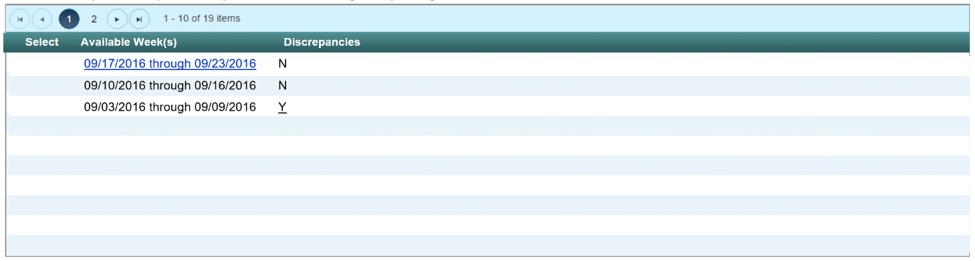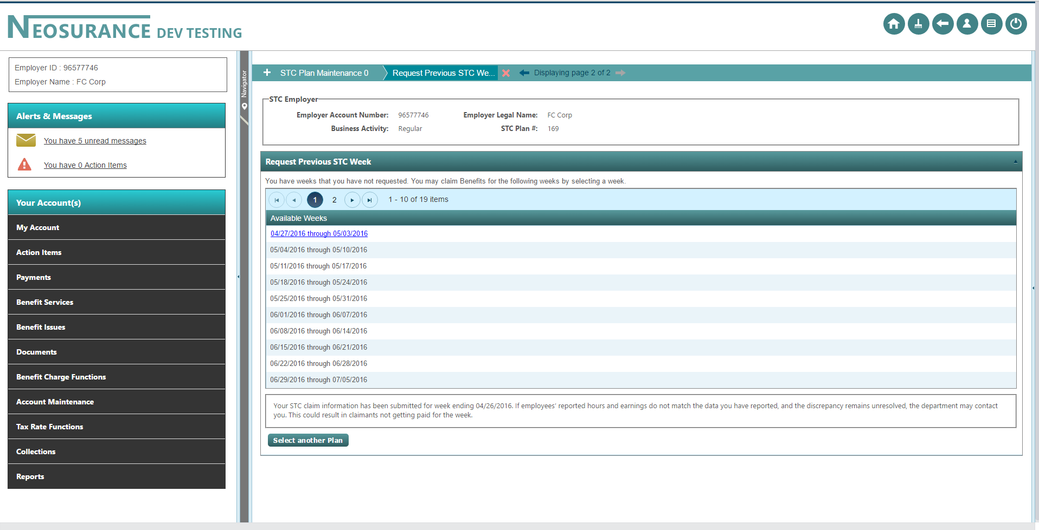

**Work Sharing Employer Information**

**File Work Sharing Claim**

Weeks with active hyperlinks are available to be certified. Click on the active hyperlink to continue to Claimant Information.

Weeks with reporting discrepancies will also have active hyperlinks. Click on the active hyperlink to resolve.

| **UI CONTROL** | **TYPE** | **DESCRIPTION** | **VALIDATION RULES** | **FIT/ GAP** | **NOTES** |
| --- | --- | --- | --- | --- | --- |
| Application Wizard | Application Wizard | System displays: Work Sharing Plan Maintenance | Read only |  |  |
| Work Sharing Employer Information | Section Header | System displays: Work Sharing Employer Information | Read only |  |  |
| Employer Account ID: | Label / Text | System displays label and the system assigned employer ID number for the employer | Read only |  |  |
| Employer Name: | Label / Text | System displays label and the employer’s legal name | Read only |  |  |
| ~~Employment Type:~~ | ~~Label / Text~~ | ~~System displays label and the employer’s employment type~~ | ~~Read only~~ |  |  |
| Work Sharing Plan ID: | Label / Text | System displays label and the Work Sharing Plan ID | Read only |  |  |
| File Work Sharing Claim | Section Header | System displays: File Work Sharing Claim  File Work Sharing Claim | Read only |  |  |
| Informational Text | Text | System displays: Weeks with active hyperlinks are available to be certified. Click on the active hyperlink to continue to Claimant Information.  Weeks with reporting discrepancies will also have active hyperlinks. Click on the active hyperlink to resolve. | Read only |  |  |
| Select | Label / Radio button | System displays the Select column header and radio button.  Allows the employer/staff to select the record | Not sortable |  |  |
| Available Weeks | Section Header | System displays: Available Weeks | Read only |  |  |
| Available Weeks | Text | System displays previously requested weeks | Read only  Date format  Sunday is begin date of the weekly certification week  Saturday is the end date of the weekly certification week |  |  |
| Available Weeks | Hyperlink | System displays available request weeks as a hyperlink | Read only  Date format  Sunday is begin date of the weekly certification week  Saturday is the end date of the weekly certification week  When selected, system navigates to the *File Work Sharing Plan Claim – Employer screen* |  |  |
| Discrepancies | Section Header | System displays: Discrepancies | Read only |  |  |
| Discrepancies | Text | System displays ‘N’ | Read only |  |  |
| Discrepancies | Hyperlink | System displays ‘Y’ as a hyperlink | Read only  When selected, system navigates to the *Review Work Sharing Plan Discrepancy Workflow* screen |  |  |

**Command Keys**

| **UI CONTROL** | **TYPE** | **DESCRIPTION** | **VALIDATION RULES** | **FIT/ GAP** | **NOTES** |
| --- | --- | --- | --- | --- | --- |
| Previous | Button | System navigates to the *Add or Modify* *Work Sharing Plan screen* |  |  |  |
| Next | Button | Grayed out and not accessible |  |  |  |
| Finish | Button | Grayed out and not accessible |  |  |  |
| Select Another Plan | Button | System navigates to the *Add or Modify* *Work Sharing Plan screen* |  |  |  |

## Screen 3 – Work Sharing Plan Weekly Continued Claim - Employer

This screen allows the employer to enter Work Sharing Plan information for each claimant for the selected weekly claim.

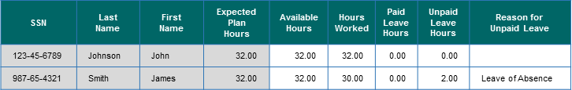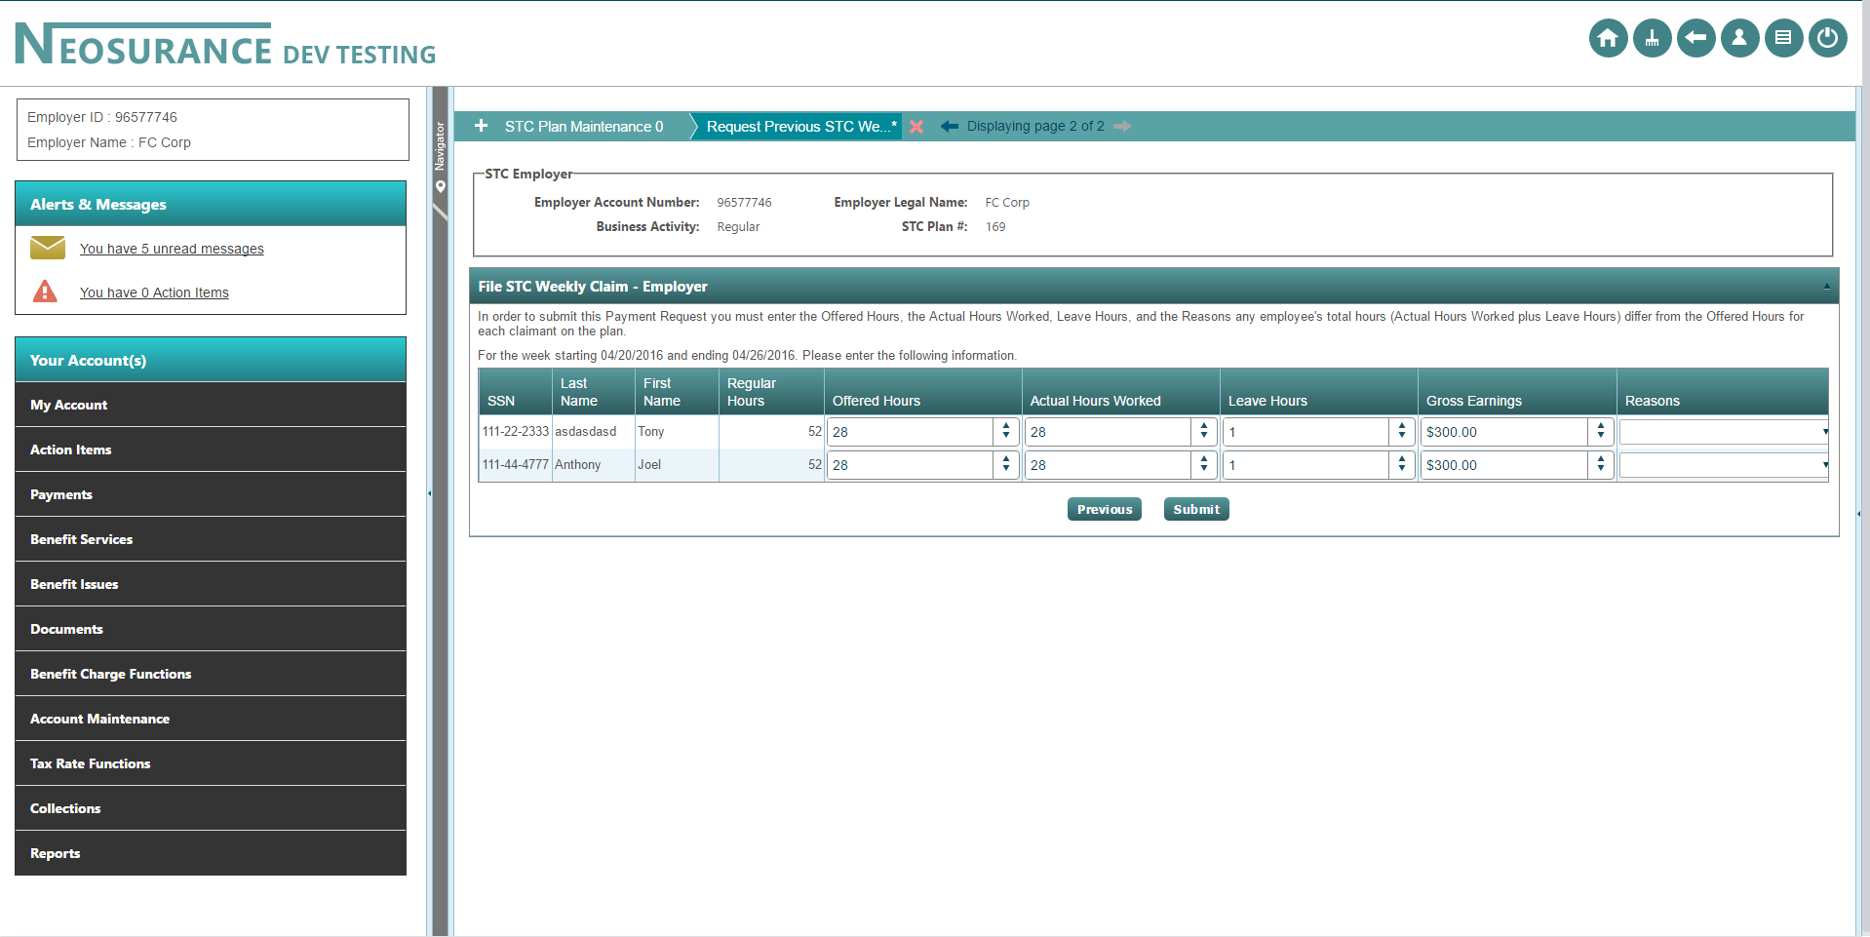

**Work Sharing Employer Information**

In order to submit this claim you must enter the ‘Available Hours’, ‘Actual Hours Worked’, ‘Paid Leave Hours’, Unpaid Leave Hours’, ‘Reasons for Unpaid Leave’.

NOTE: UNPAID LEAVE: Report hours in this column that were AVAILABLE but your employee did not work and did not receive payment. PAID LEAVE HOURS are considered WORKED HOURS for Work Sharing participants.

For the week <ddmmyyy to ddmmyyyy> enter the employee Work Sharing hours. Provide information as it pertains to this week only.

**Work Sharing Weekly Continued Claim**

**File Work Sharing Claim**

| **UI CONTROL** | **TYPE** | **DESCRIPTION**  **Employer Account ID: 96512312 Employer Name: FC Corp Work Sharing Plan ID:** 10374  **Work Sharing Employer** | **VALIDATION RULES** | **FIT/ GAP** | **NOTES** |
| --- | --- | --- | --- | --- | --- |
| Application Wizard | Application Wizard | System displays: Work Sharing Plan Maintenance | Read only |  |  |
| Work Sharing Employer Information | Section Header | System displays: Work Sharing Employer Information | Read only |  |  |
| Employer Account ID: | Label / Text | System displays label and the system assigned employer ID number for the employer | Read only |  |  |
| Business Name: | Label / Text | System displays label and the employer’s legal name | Read only |  |  |
| Work Sharing Plan Number: | Label / Text | System displays label and the Work Sharing Plan number | Read only |  |  |
| File Work Sharing Plan Claim | Section Header | System displays: File Work Sharing Plan Claim | Read only |  |  |
| Informational Text | Text | System displays:  “In order to submit this claim you must enter the ‘Available Hours’, ‘Actual Hours Worked’, ‘Paid Leave Hours’, Unpaid Leave Hours’, ‘Reasons for Unpaid Leave’.  NOTE: UNPAID LEAVE: Report hours in this column that were AVAILABLE but your employee did not work and did not receive payment. PAID LEAVE HOURS are considered WORKED HOURS for Work Sharing participants.  For the week <ddmmyyy to ddmmyyyy> enter the employee Work Sharing hours. Provide information as it pertains to this week only.’ | Read only  Date format  Sunday is begin date of the weekly certification week  Saturday is the end date of the weekly certification week |  |  |
| SSN | Column Header / Text | System displays column header and the claimant SSN | Read only  Numeric  Display as 999-99-9999  Sortable  Any column header when clicked, should sort that column in the ascending order first, if clicked again it should be sorted in descending order |  |  |
| Last Name | Column Header / Text | System displays column header and the claimant last name | Read only  Sortable  Any column header when clicked, should sort that column in the ascending order first, if clicked again it should be sorted in descending order |  |  |
| First Name | Column Header / Text | System displays column header and the claimant first name | Read only  Sortable  Any column header when clicked, should sort that column in the ascending order first, if clicked again it should be sorted in descending order |  |  |
| Expected Plan Hours | Column Header / Text | System displays column header and the claimant’s expected plan hours | Read only  Sortable  Any column header when clicked, should sort that column in the ascending order first, if clicked again it should be sorted in descending order |  |  |
| Available Hours | Column Header / Text Box | System displays label and allows the user to enter the corresponding data | Required  Numeric  Value must be between zero (20) and forty (40)  Format 99.99  Sortable  Any column header when clicked, should sort that column in the ascending order first, if clicked again it should be sorted in descending order |  |  |
| Hours Worked | Column Header / Text Box | System displays column header and allows the user to enter the corresponding data | Required  Numeric  Value must be between zero (20) and forty (40)  Format 99.99  Sortable  Any column header when clicked, should sort that column in the ascending order first, if clicked again it should be sorted in descending order |  |  |
| Paid Leave Hours | Column Header / Text Box | System displays column header and allows the user to enter the corresponding data | Required  Numeric  Value must be between zero (0) and forty (40)  Format 99.99  Sortable  Any column header when clicked, should sort that column in the ascending order first, if clicked again it should be sorted in descending order |  |  |
| Unpaid Leave Hours | Column Header / Text Box | System displays column header and allows the user to enter the corresponding data | Required  Numeric  Value must be between zero (0) and forty (40)  Format 99.99  Sortable  Any column header when clicked, should sort that column in the ascending order first, if clicked again it should be sorted in descending order |  |  |
| Reasons | Column Header / Drop-Down | System displays label and allows the user to select a value from the drop-down | Required, if Unpaid Leave Hours > 0  Allowable values are:   * Null * Discharged * Lack of Work/Company Shutdown * Leave of Absence * Refusal of Available Hours * Sick/Family Medical Leave * Vacation/Personal Leave * Quit * Other   Default value is null |  |  |

**Command Keys**

| **UI CONTROL** | **TYPE** | **DESCRIPTION** | **VALIDATION RULES** | **FIT/ GAP** | **NOTES** |
| --- | --- | --- | --- | --- | --- |
| Submit | Button | System navigates to the *File Work Sharing Plan Claim Confirmation screen* | Updates are saved |  |  |
| Previous | Button | System navigates to the *Work Sharing Plan screen* | Updates are not saved |  |  |
| Next | Button | Grayed out and not accessible |  |  |  |
| Finish | Button | Grayed out and not accessible |  |  |  |

## Screen 4 – Review and Submit screen – Employer

**Work Sharing Employer Information**



**Work Sharing Employer Information**

The information provided below is for the week of Sunday, [mm/dd/yyyy] through Saturday, [mm/dd/yyyy].

Review the entries to ensure its accuracy. Once completed, click the ‘Acknowledgement’ checkbox and then ‘Finish’ button to complete your submission.”

**Work Sharing Continued Claim**

Information provided that is not in compliance with your approved plan or is different from the information entered by the participating employee may result in a delay or denial of payment.

I certify that the hours and information provided for each employee participating in the Work Sharing Program is true and correct to the best of my knowledge.

**Acknowledgement**

| UI CONTROL | TYPE | DESCRIPTION | VALIDATION RULES | FIT/ GAP | NOTES |
| --- | --- | --- | --- | --- | --- |
| Application Wizard | Application Wizard | System displays: Work Sharing Plan Maintenance | Read only |  |  |
| Work Sharing Employer Information | Section Header | System displays: Work Sharing Employer Information | Read only |  |  |
| Employer Account ID: | Label / Text | System displays label and the system assigned employer ID number for the employer | Read only |  |  |
| Business Name: | Label / Text | System displays label and the employer’s legal name | Read only |  |  |
| Work Sharing Plan Number: | Label / Text | System displays label and the Work Sharing Plan number | Read only |  |  |
| Review and Submit | Section Header | System displays: Review and Submit | Read only |  |  |
| Informational Text | Text | System displays:  “The information provided below is for the week of Sunday, [mm/dd/yyyy] through Saturday, [mm/dd/yyyy].  Review the entries to ensure its accuracy. Once completed, click the ‘Acknowledgement’ checkbox and then ‘Finish’ button to complete your submission.” | Read only  Date format  Sunday is begin date of the weekly certification week  Saturday is the end date of the weekly certification week |  |  |
| SSN | Column Header / Text | System displays column header and the claimant SSN | Read only  Numeric  Display as 999-99-9999  Sortable  Any column header when clicked, should sort that column in the ascending order first, if clicked again it should be sorted in descending order |  |  |
| Last Name | Column Header / Text | System displays column header and the claimant last name | Read only  Sortable  Any column header when clicked, should sort that column in the ascending order first, if clicked again it should be sorted in descending order |  |  |
| First Name | Column Header / Text | System displays column header and the claimant first name | Read only  Sortable  Any column header when clicked, should sort that column in the ascending order first, if clicked again it should be sorted in descending order |  |  |
| Expected Plan Hours | Column Header / Text | System displays column header and the claimant’s expected plan hours | Read only  Sortable  Any column header when clicked, should sort that column in the ascending order first, if clicked again it should be sorted in descending order |  |  |
| Available Hours | Column Header / Text Box | System displays label and allows the user to enter the corresponding data | Required  Numeric  Value must be between zero (20) and forty (40)  Format 99.99  Sortable  Any column header when clicked, should sort that column in the ascending order first, if clicked again it should be sorted in descending order |  |  |
| Hours Worked | Column Header / Text Box | System displays column header and allows the user to enter the corresponding data | Required  Numeric  Value must be between zero (20) and forty (40)  Format 99.99  Sortable  Any column header when clicked, should sort that column in the ascending order first, if clicked again it should be sorted in descending order |  |  |
| Paid Leave Hours | Column Header / Text Box | System displays column header and allows the user to enter the corresponding data | Required  Numeric  Value must be between zero (0) and forty (40)  Format 99.99  Sortable  Any column header when clicked, should sort that column in the ascending order first, if clicked again it should be sorted in descending order |  |  |
| Unpaid Leave Hours | Column Header / Text Box | System displays column header and allows the user to enter the corresponding data | Required  Numeric  Value must be between zero (0) and forty (40)  Format 99.99  Sortable  Any column header when clicked, should sort that column in the ascending order first, if clicked again it should be sorted in descending order |  |  |
| Reasons | Column Header / Drop-Down | System displays label and allows the user to select a value from the drop-down | Required, if Unpaid Leave Hours > 0  Allowable values are:   * Null * Discharged * Lack of Work/Company Shutdown * Leave of Absence * Refusal of Available Hours * Sick/Family Medical Leave * Vacation/Personal Leave * Quit * Other   Default value is null |  |  |
| Acknowledgement | Section Header | System displays:  Acknowledgment | Read only |  |  |
| Informational Text | Checkbox / Label | System displays ‘Information provided that is not in compliance with your approved plan or is different from the information entered by the participating employee may result in a delay or denial of payment.  I certify that the hours and information provided for each employee participating in the Work Sharing Program is true and correct to the best of my knowledge.’  System allows the user to select the checkbox | Required |  |  |

**Command Keys**

| **UI CONTROL** | **TYPE** | **DESCRIPTION** | **VALIDATION RULES** | **FIT/ GAP** | **NOTES** |
| --- | --- | --- | --- | --- | --- |
| Previous | Button | Grayed out and not accessible |  |  |  |
| Next | Button | System navigates to the *Employer Confirmation* screen |  |  |  |
| Finish | Button | Grayed out and not accessible |  |  |  |

## Screen 5 – Employer Confirmation screen

The ‘Employer Confirmation screen

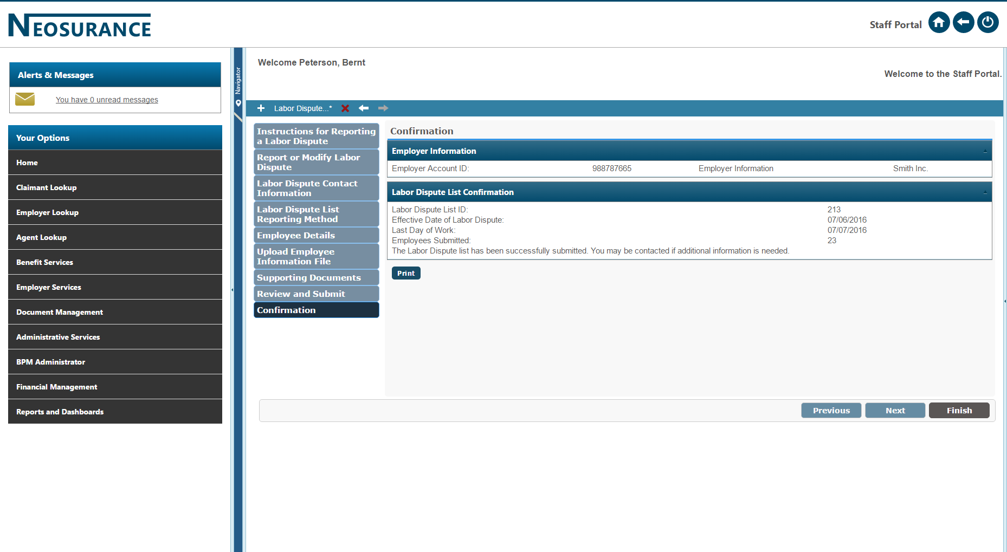

Your Work Sharing report for the week of Sunday, MM/DD/YYYY through Saturday, MM/DD/YYYY has been received on: <Date submitted> <Time submitted> (EST)

**Important:** If you need to make any corrections please contact the Work Sharing coordinator at ui.worksharing@maryland.gov during business hours. You must do this as soon as possible to avoid potential over-payments for participating employees.

Participating employees should be encouraged to establish an on-line claimant portal. This is the most efficient method for receiving notifications and filing weekly certifications.

**Work Sharing Continued Claim Confirmation**

**Work Sharing Employer Information**

**Employer Account ID: 96512312 Employer Name: FC Corp Work Sharing Plan ID:** 10374

| **UI CONTROL** | **TYPE** | **DESCRIPTION** | **VALIDATION RULES** | **FIT/**  **GAP** | **NOTES** |
| --- | --- | --- | --- | --- | --- |
| Application Wizard | Progress Bar | Step 3: Confirmation |  | Fit |  |
| Breadcrumbs | Context based Navigation | Displays ‘breadcrumbs’ indicating screens that have been completed and current screen location; Confirmation | Displays to the left of the screen | Fit |  |
| Header | Header Text | System displays: Confirmation |  | Fit |  |
| Sub Header | Sub Header Text | System displays: Employer Information |  | Fit |  |
| Employer Account ID | Label / Text | System displays the employer account ID | Read Only | Fit |  |
| Employer Name | Label / Text | System displays the employer name | Read Only | Fit |  |
| Work Sharing ID | Label / Text | System displays the Work Sharing ID: | Read Only | Gap |  |
| Sub Header | Sub Header Text | System displays: Work Sharing Weekly Continued Claim Confirmation |  | Fit |  |
| Text | Text | System displays:  Your Work Sharing report for the week of Sunday, MM/DD/YYYY through Saturday, MM/DD/YYYY has been received on: <Date submitted> <Time submitted> (EST)  **Important:** If you need to make any corrections please contact the Work Sharing coordinator, ui.worksharing@maryland.gov during business hours. You must do this as soon as possible to avoid potential over-payments for participating employees.  Participating employees should be encouraged to establish an on-line claimant portal. This is the most efficient method for receiving notifications and filing weekly certifications. | Read Only | GAP |  |
| Print | Button | System provides the ability to print the confirmation information including all of the weekly continued claims information. |  |  |  |

**Command Keys**

| **UI CONTROL** | **TYPE** | Should be grayed out and not accessible | **VALIDATION RULES** | **FIT/GAP** | **NOTES** |
| --- | --- | --- | --- | --- | --- |
| Previous | Button | Should be grayed out and not accessible |  | Fit |  |
| Next | Button | Should be grayed out and not accessible |  | Fit |  |
| Finish | Button | Navigates the user to the *User Home Page* |  | Fit |  |

## Screen 6 – Work Sharing Hours – Claimant

This screen presents the claimant with initial questions required for completing a Work Sharing weekly certification.

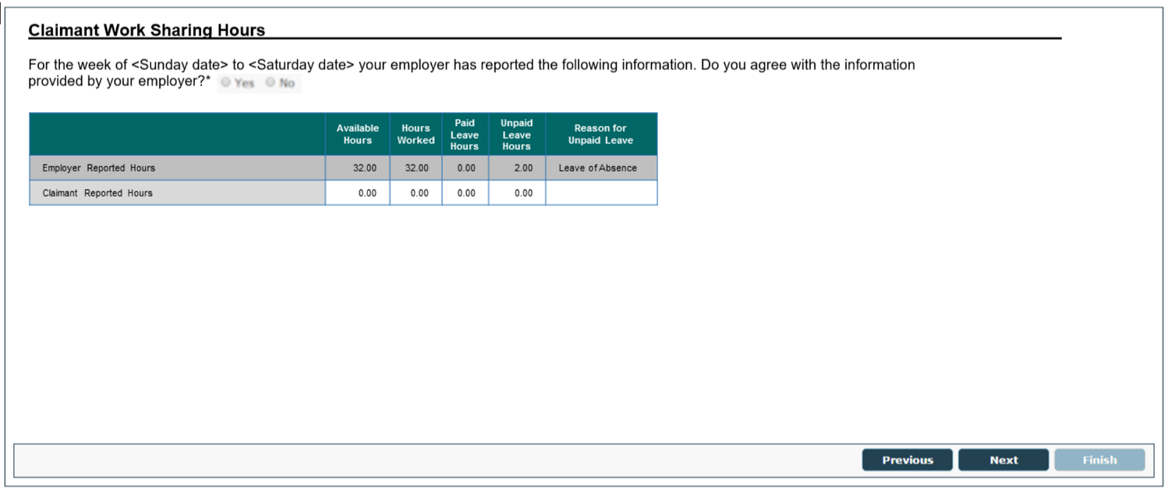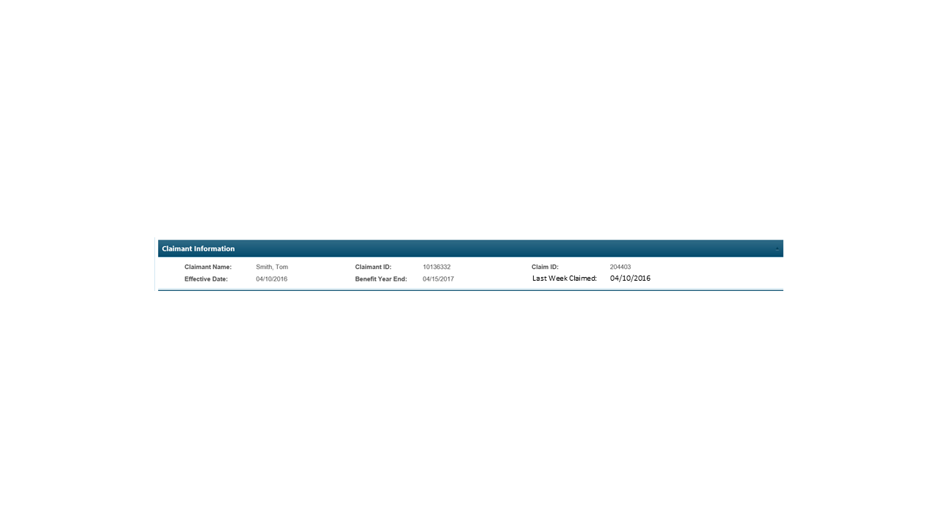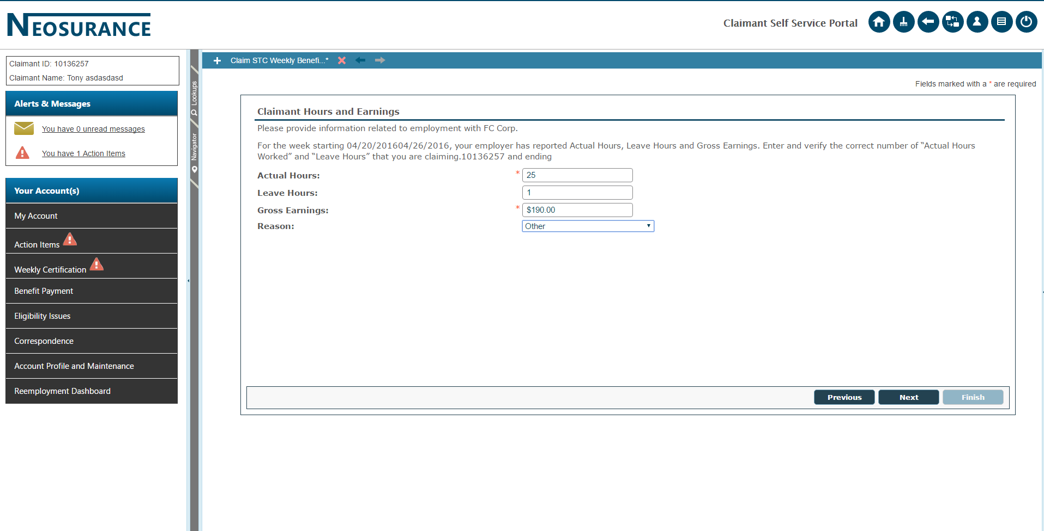

**Claimant Work Sharing Hours**

| **UI CONTROL** | **TYPE** | **DESCRIPTION** | **VALIDATION RULES** | **FIT/ GAP** | | **NOTES** | |
| --- | --- | --- | --- | --- | --- | --- | --- |
| Application Wizard | Application Wizard | System displays: Weekly Certification Wizard |  |  |  | |
| Progress Bar | Progress Bar | System displays:  Step 1: Claimant Work Sharing Hours  Step 2: Review and  Submit  Step 3: Confirmation | Read only  Highlight Step 1 |  |  | |
| Breadcrumbs | Context Based Navigation | System displays ‘breadcrumbs’ indicating screens that have been completed and current screen location: Claimant Work Sharing Hours |  |  |  | |
| Work Sharing Hours | Screen Title | System displays: Claimant Work Sharing Hours |  |  |  | |
| Claimant Information | Section Header | System displays: Claimant Information | Read only |  |  | |
| Claimant Name: | Label / Text | System displays label and the claimants last name and first name | Read only |  |  | |
| Claimant ID: | Label / Text | System displays label and the claimant ID number for the claimant | Read only |  |  | |
| Claim ID: | Label / Text | System displays label and the claimant’s most recent claim ID number | Read only |  |  | |
| Effective Date: | Label / Text | System displays label and the effective date of the claim ID displayed | Read only |  | EFFECTIVE_BEGIN_DATE on the SGT_MONETARY_HEADER table | |
| Benefit Year End: | Label / Text | System displays label and the BYE date for the claim ID displayed | Read only |  | EFFECTIVE_END_DATE on the SGT_MONETARY_HEADER table | |
| Last Week Claimed: | Label / Text | System displays label and the last week claimed for the claim ID displayed | Read only  Display ‘N/A’ if not available |  |  | |
| Informational Text | Text | Employer Submitted Information |  |  |  | |
| Available Hours | Column Header / Text Box | System displays label and employer submitted weekly continued claim available hours | Read Only |  |  | |
| Hours Worked | Column Header / Text Box | System displays label and employer submitted weekly continued claim hours worked | Read Only |  |  | |
| Paid Leave Hours | Column Header / Text Box | System displays label and employer submitted weekly continued claim paid leave hours | Read Only |  |  | |
| Unpaid Leave Hours | Column Header / Text Box | System displays label and employer submitted weekly continued claim unpaid leave hours | Read Only |  |  | |
| Reasons | Column Header / Drop-Down | System displays label and employer submitted weekly continued claim reasons for unpaid leave hours | Read Only |  |  | |
| Agree/Disagree | Text / Radio Buttons | System displays the following text “For the week of <Sunday date> to <Saturday date> your employer has reported the following information. Do you agree with the information provided by your employer?” and allows the user to select a radio button | Required  Allowable values are:   * Yes * No |  |  | |
| Available Hours | Column Header / Text Box | System displays label and allows the user to enter the corresponding data | Display if Agree/Disagree = No  Required  Numeric  Value must be between zero (20) and forty (40)  Format 99.99 |  |  | |
| Hours Worked | Column Header / Text Box | System displays column header and allows the user to enter the corresponding data | Display if Agree/Disagree = No  Required  Numeric  Value must be between zero (20) and forty (40)  Format 99.99 |  |  | |
| Paid Leave Hours | Column Header / Text Box | System displays column header and allows the user to enter the corresponding data | Display if Agree/Disagree = No  Required  Numeric  Value must be between zero (0) and forty (40)  Format 99.99 |  |  | |
| Unpaid Leave Hours | Column Header / Text Box | System displays column header and allows the user to enter the corresponding data | Display if Agree/Disagree = No  Required  Numeric  Value must be between zero (0) and forty (40)  Format 99.99 |  |  | |
| Reasons for Unpaid Leave | Column Header / Drop-Down | System displays label and allows the user to select a value from the drop-down | Display if Agree/Disagree = No  Required, if Unpaid Leave Hours > 0  Allowable values are:   * Null * Discharged * Lack of Work/Company Shutdown * Leave of Absence * Refusal of Available Hours * Sick/Family Medical Leave * Vacation/Personal Leave * Quit * Other   Default value is null |  |  | |

**Command Keys**

| **UI CONTROL** | **TYPE** | **DESCRIPTION** | **VALIDATION RULES** | **FIT/ GAP** | **NOTES** |
| --- | --- | --- | --- | --- | --- |
| Previous | Button | System navigates to the *Process Weekly Certification screen* | Updates are not saved |  |  |
| Next | Button | System navigates to the *Review and Submit screen* | Updates are saved |  |  |
| Finish | Button | Grayed out and not accessible |  |  |  |

## Screen 7 – Review and Submit - Claimant

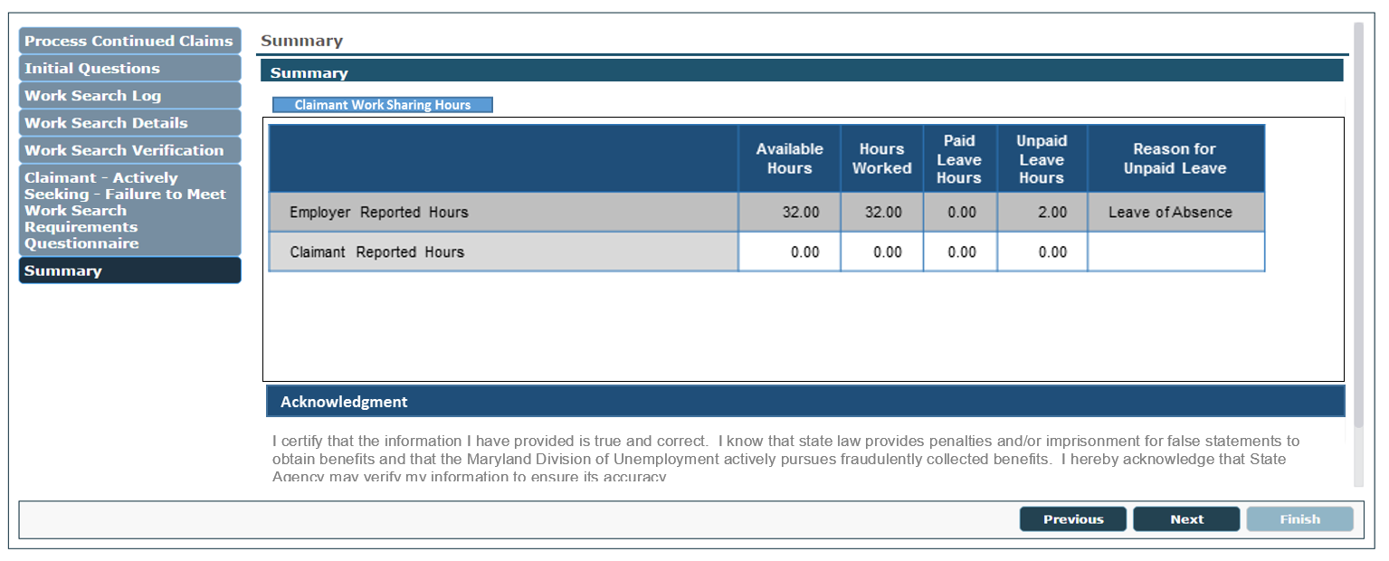This screen presents the claimant with their responses to initial questions required for completing a Work Sharing weekly certification. The claimant can then accept the certification or return to the to change their reponse. 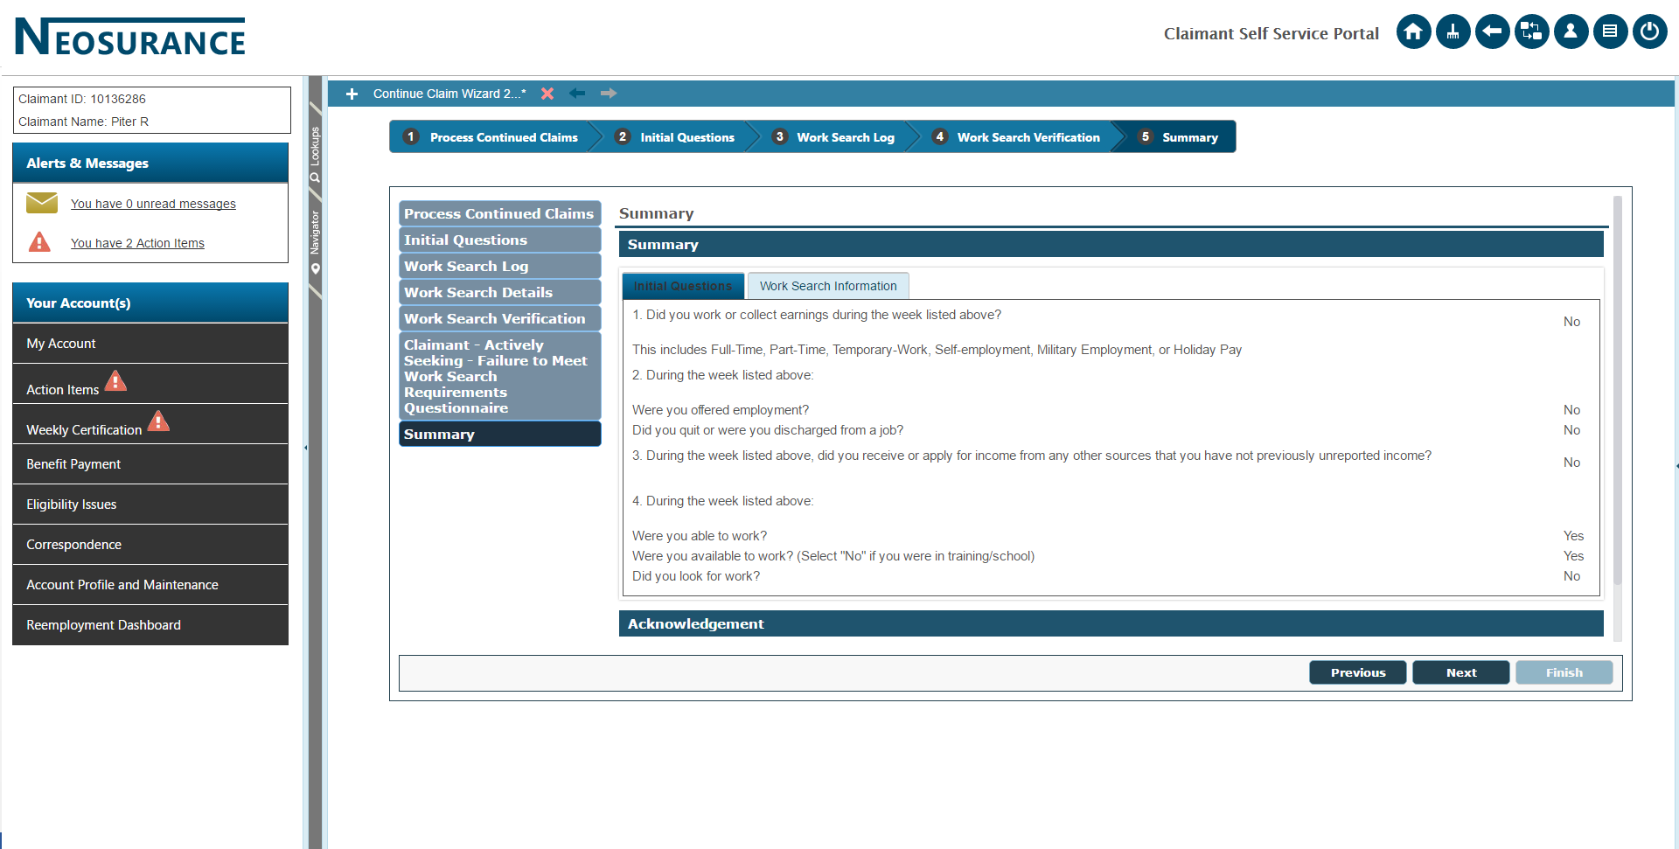

| **UI CONTROL** | **TYPE** | **DESCRIPTION** | **VALIDATION RULES** | **FIT/ GAP** | **NOTES** |
| --- | --- | --- | --- | --- | --- |
| Application Wizard | Application Wizard | System displays: Weekly Certification Wizard | Read only |  |  |
| Progress Bar | Progress Bar | System displays:  Step 1: Claimant Work Sharing Hours  Step 2: Review and  Submit  Step 3: Confirmation | Read only  Highlight Step 2 |  |  |
| Breadcrumbs | Context Based Navigation | System displays ‘breadcrumbs’ indicating screens that have been completed and current screen location: Review and Submit | Display to the left of the screen |  |  |
| Review and Submit | Screen Title | System displays:  Review and Submit | Read only |  |  |
| Claimant Information | Section Header | System displays: Claimant Information | Read only |  |  |
| Claimant Name: | Label / Text | System displays label and the claimants last name and first name | Read only |  |  |
| Claimant ID: | Label / Text | System displays label and the claimant ID number for the claimant | Read only |  |  |
| Claim ID: | Label / Text | System displays label and the claimant’s most recent claim ID number | Read only |  |  |
| Effective Date: | Label / Text | System displays label and the effective date of the claim ID displayed | Read only |  | EFFECTIVE_BEGIN_DATE on the SGT_MONETARY_HEADER table |
| Benefit Year End: | Label / Text | System displays label and the BYE date for the claim ID displayed | Read only |  | EFFECTIVE_END_DATE on the SGT_MONETARY_HEADER table |
| Last Week Claimed: | Label / Text | System displays label and the last week claimed for the claim ID displayed | Read only   * Display ‘N/A’ if not available |  |  |
| Tab | Label / Text | System displays: ‘Claimant Work Sharing Hours’ tab and all questions that were presented on the *Claimant Work Sharing Hours screen*, along with claimant responses | Read only |  |  |
| Edit | Button | System navigates to the *Claimant Work Sharing Hours screen* and allows the claimant to edit answers |  |  |  |
| Acknowledgement | Section Header | System displays:  Acknowledgment | Read only |  |  |
| Informational Text | Checkbox / Label | System displays ‘I certify that the information I have provided is true and correct. I know that state law provides penalties and/or imprisonment for false statements to obtain benefits and that the Maryland Division of Unemployment actively pursues fraudulently collected benefits. I hereby acknowledge that State Agency may verify my information to ensure its accuracy.’  System allows the user to select the checkbox | Required |  |  |

**Command Keys**

| **UI CONTROL** | **TYPE** | **DESCRIPTION** | **VALIDATION RULES** | **FIT/ GAP** | **NOTES** |
| --- | --- | --- | --- | --- | --- |
| Previous | Button | System navigates to the *Claimant Work Sharing Hours screen* |  |  |  |
| Next | Button | System navigates to the *Confirmation screen* | Updates are saved |  |  |
| Finish | Button | Grayed out and not accessible |  |  |  |

## Screen 8 – Confirmation Screen – Claimant





**Work Sharing Contunued Claim Confirmation**

Your request for benefits for the week of Sunday, MM/DD/YYYY through Saturday, MM/DD/YYYY has been received on: <Date submitted> <Time submitted> (EST)”

Your confirmation number is ********. You should print or keep a written record of this number; it is your proof that the weekly certification was filed.

**Conditional message if claimant worked hours plus paid leave hours are greater than expected reduction: Your Work Sharing hours for** MM/DD/YYYY through Saturday, MM/DD/YYYY were greater than the number allowed on the approved Work Sharing Plan. Benefits are not payable for this week.

**Important: If you think that you made a mistake when you answered the questions on this weekly certification** you must contact a claim representative during business hours to correct the information. You must do this as soon as possible to avoid potential over-payments and possible penalties for fraud.

Remember:

* **It is against the law to make false statements during the weekly certification process in order to receive benefits.** You may be subject to interest and penalties, including the loss of benefits or even criminal prosecution.
* You must claim weekly benefits yourself. Do not give out your username, password or PIN. **If you allow someone else to file your weekly claim certification for you or access your claim online or over the phone system, you can be subject to severe penalties**.
* To keep your address, phone number and email address current.

***Link directly to payment history*** PAYMENT HISTORY

***Link to inbox/or correspondence*** INBOX

## Screen 10 – Review Work Sharing Plan Discrepancy Workflow

This screen allows agency staff or the employer to review both employer and claimant entered information for the weekly continued claim and review the discrepancy.

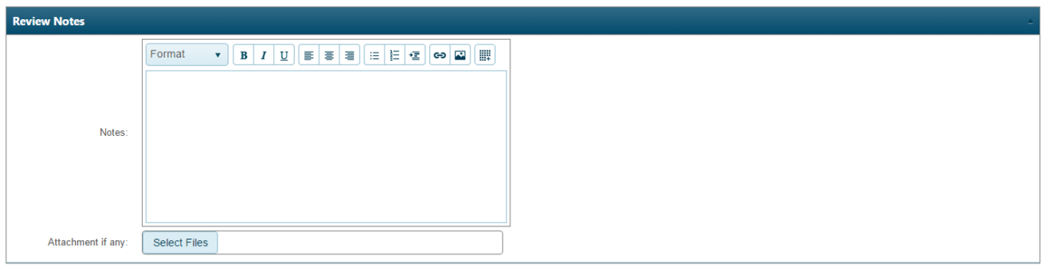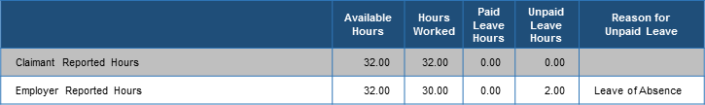 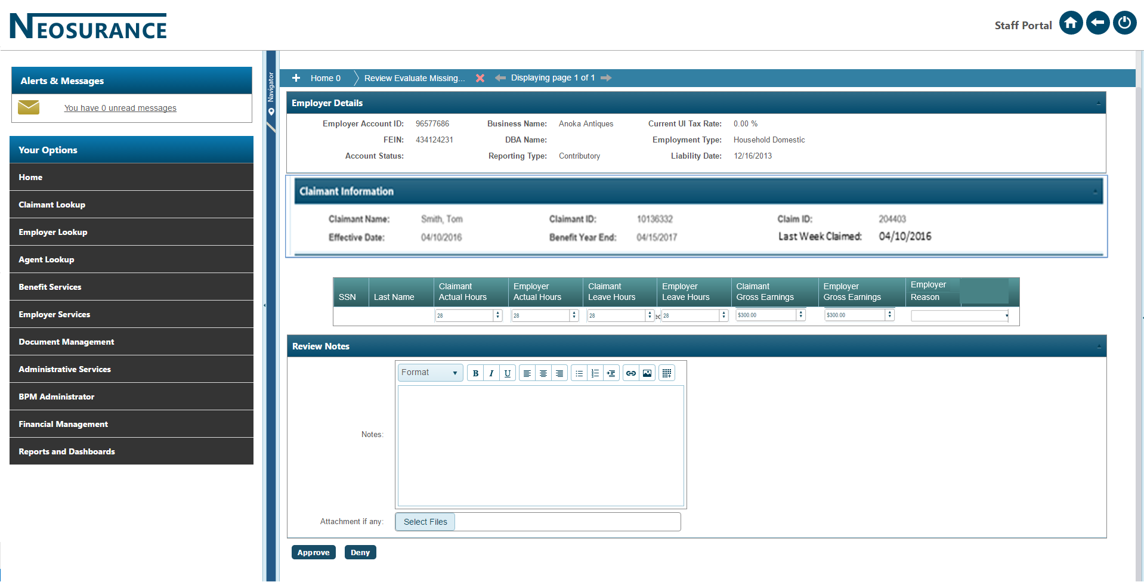

**Work Sharing Employer Information**

**Work Sharing Plan Discrepancy**

The data below includes the hours reported by you for the claimant. Also, shown below are the hours reported by the claimant for the week, which are different from those you reported.

Review the data and make any modifications to the hours you originally reported, if you agree with what was reported by the claimant. If any of the hours or reason for unpaid leave by you and the claimant do not match after you re-submit this weekly claim, the department agency staff will contact you to resolve the discrepancy.

Review and update the following information for the week of Sunday, [mm/dd/yyyy] through Saturday, [mm/dd/yyyy].”

SSN: 123-45-6789 Last Name: Johnson First Name: John

**Employer Account ID: 96512312 Employer Name: FC Corp Work Sharing Plan ID:** 10374

| **UI CONTROL** | **TYPE** | **DESCRIPTION** | | **VALIDATION RULES** | **FIT/ GAP** | | | | | **NOTES** | |
| --- | --- | --- | --- | --- | --- | --- | --- | --- | --- | --- | --- |
| Application Wizard | Application Wizard | System displays: Review Work Sharing Plan Discrepancy | | Read only |  | | | | |  | |
| Work Sharing Employer Information | Section Header | System displays: Work Sharing Employer Information | | Read only |  | | | | |  | |
| Employer Account ID: | Label / Text | System displays label and the system assigned employer ID number for the employer | | Read only |  | | | | |  | |
| Business Name: | Label / Text | System displays label and the employer’s legal name | | Read only |  | | | | |  | |
| Work Sharing ID: | Label / Text | System displays label and the Work Sharing Plan ID | | Read only |  | | | | |  | |
| Work Sharing Plan Claim Discrepancy | Section Header | System displays: Work Sharing Plan Claim Discrepancy | | Read only |  | | | | |  | |
| Informational Text | Text | System displays:  “The data below includes the hours reported by you for the claimant. Also, shown below are the hours reported by the claimant for the week, which are different from those you reported.  Review the data and make any modifications to the hours you originally reported, if you agree with what was reported by the claimant. If any of the hours or reason for unpaid leave by you and the claimant do not match after you re-submit this weekly claim, the Department agency staff will contact you to resolve the discrepancy.  Review and update the following information for the week of Sunday, [mm/dd/yyyy] through Saturday, [mm/dd/yyyy].” | | Read only  Date format  Sunday is begin date of the weekly certification week  Saturday is the end date of the weekly certification week |  | | | | |  | |
| SSN: | Label / Text | System displays label and the claimant SSN | | Read only  Numeric  Display as 999-99-9999 |  | | | | |  | |
| Last Name: | Label / Text | System displays label and the claimant last name | | Read only |  | | | | |  | |
| First Name: | Label / Text | System displays label and the claimant first name | | Read only |  | | | | |  | |
| Expected Plan Hours: | Label / Text | System displays label and the claimant’s expected plan hours | | Read only |  | | | | |  | |
| Available Hours | Column Header | System displays column header | |  |  | | | | |  | |
| Hours Worked | Column Header | System displays column header | |  |  | | | | |  | |
| Paid Leave Hours | Column Header | System displays column header | |  |  | | | | |  | |
| Unpaid Leave Hours | Column Header | System displays column header | |  |  | | | | |  | |
| Reasons | Column Header | System displays column header | |  |  | | | | |  | |
| Informational Text | Text | System displays: ‘Reported by Claimant’ | |  |  | | | | |  | |
| Claimant Available Hours | Text Box | System displays the claimant’s entered available hours | |  |  | | | | |  | |
| Claimant Hours Worked | Text Box | System displays the claimant’s entered hours worked | | Read Only  Numeric  Value must be between zero (0) and forty (40)  Pre-populated with hours from the previously submitted claimant weekly continued claim  Sortable  Any column header when clicked, should sort that column in the ascending order first, if clicked again it should be sorted in descending order |  | | | | |  | |
| Claimant Paid Leave Hours | Text Box | System displays the claimant’s entered paid leave hours | Read Only  Numeric  Value must be between zero (0) and forty (40)  Pre-populated with hours from the previously submitted claimant weekly continued claim | | | |  | |  | |
| Claimant Unpaid Leave Hours | Text Box | System displays the claimant’s entered unpaid leave hours | Read Only  Numeric  Value must be between zero (0) and forty (40)  Pre-populated with hours from the previously submitted claimant weekly continued claim | | |  | |  | | | |
| Claimant Reasons | Text Box | System displays the claimant’s entered reasons for unpaid leave hours | Read Only  Pre-populated with reasons from the previously submitted claimant weekly continued claim | | |  | |  | | | |
| Informational Text | Text | System displays: ‘Reported by Employer’ |  | | | |  | | |  |
| Employer Available Hours | Text Box | System allows the user to enter the corresponding data | Required  Numeric  Value must be between zero (0) and forty (40)  Pre-populated with hours from the previously submitted employer weekly claim  Sortable  Any column header when clicked, should sort that column in the ascending order first, if clicked again it should be sorted in descending order | | | |  | | |  |
| Employer Hours Worked | Text Box | System allows the user to enter the corresponding data | Required  Numeric  Value must be between zero (0) and forty (40)  Pre-populated with hours from the previously submitted employer weekly claim  Sortable  Any column header when clicked, should sort that column in the ascending order first, if clicked again it should be sorted in descending order | | | |  | | |  |
| Employer Paid Leave Hours | Text Box | System displays allows the user to enter the corresponding data | Required  Numeric  Value must be between zero (0) and forty (40)  Pre-populated with hours from the previously submitted employer weekly claim  Sortable  Any column header when clicked, should sort that column in the ascending order first, if clicked again it should be sorted in descending order | | | |  | | |  |
| Employer Unpaid Leave Hours | Text Box | System allows the user to enter the corresponding data | Required  Numeric  Value must be between zero (0) and forty (40)  Pre-populated with hours from the previously submitted employer weekly claim  Sortable  Any column header when clicked, should sort that column in the ascending order first, if clicked again it should be sorted in descending order | | | |  | | |  |
| Employer Reasons | Text Box | System allows the user to select a value from the drop-down | Required, if Unpaid Leave Hours > 0  Pre-populated with reasons from the previously submitted employer weekly claim  Allowable values are:   * Null * Discharged * Lack of Work/Company Shutdown * Leave of Absence * Refusal of Available Hours * Sick/Family Medical Leave * Vacation/Personal Leave * Quit * Other   Default value is null | | | |  | | |  |
| Informational Text | Checkbox / Label | System displays ‘I certify the Work Sharing Plan claim information is correct and I understand the requirements for remaining eligible under this Work Sharing Plan.’  System allows the user to select the checkbox | Required | | | |  | | |  |
| Review Notes | Section Header | System displays: Review Notes | Read only | | | |  | | |  |
| Notes | Label / Text Field | System displays label and allows the user to enter the corresponding data | Optional  Alphanumeric | | | |  | | |  |
| Attachment if any: | Label / Text | System displays label and “Attachment if any:” | Read only | | | |  | | |  |
| Select Files | Button | When selected, system opens the browser window and allows the user to select a file to upload | When selected, system uploads file, highlights file name green, and adds ‘100%’ behind file name  File types allowed:   * TXT * Word * PDF | | | |  | | |  |
|  |  |  |  | | | |  | | |  |

**Command Keys**

| **UI CONTROL** | **TYPE** | **DESCRIPTION** | **VALIDATION RULES** | **FIT/ GAP** | **NOTES** |
| --- | --- | --- | --- | --- | --- |
| Submit | Button | Allows user to submit changes to the Work Sharing Plan hours |  |  |  |

**Command Keys**

| **UI CONTROL** | **TYPE** | **DESCRIPTION** | **VALIDATION RULES** | **FIT/ GAP** | **NOTES** |
| --- | --- | --- | --- | --- | --- |
| Previous | Button | System navigates to the *Work Sharing Plan screen* | Updates are not saved |  |  |
| Next | Button | System navigates to the next Work Sharing Plan Discrepancy for the current Work Sharing Plan ID and claim week |  |  |  |
| Finish | Button | Grayed out and not accessible |  |  |  |



# INTEGRATION POINTS

This use case will interact with the following use cases:

| USE CASE | DESCRIPTION |
| --- | --- |
| Setup or Modify Work Sharing Plan | User creates plan or can modify based on rules, also has workflow and correspondence for approval/denial/ discrepancy |
| Process and Issue Weekly Certification Payment | This process will validate the status of the claim, calculate the authorized payment amount for the weekly certification, and determine the distribution of the authorized payment. The system will then issue a payment or generate a reason for the nonpayment. This use case ends when weekly certification has been processed. |
| Create New Issue | Contains the functionality necessary for agency staff or the system to create a new non-monetary issue. |
| Determine Eligible Function | The purpose of this use case is to offer the claimant the appropriate navigation options. It begins after the claimant has successfully logged into the system or navigated to the Claimant Home Page. The use case provides important feedback to the claimant and provides steps he/she needs/should take via messages on the claimant Home Page. Use case ends when the claimant selects an option and the system interacts with the selected use case. |

# INTERFACES

No interfaces have been identified for this use case.

# REPORTS

No reports have been identified for this use case.

# COMMUNICATION

Communication within this use case:

| CORRESPONDENCE | DESCRIPTION | SPS |
| --- | --- | --- |
| Claimant Weekly Certification | Claimant weekly certification answers and fact finding questionnaires, if applicable, in PDF | <SPS doc hyperlink> |
| Employer Weekly Certification | Employer weekly certification answers and fact finding questionnaires, if applicable, in PDF | <SPS doc hyperlink> |

| ACCOUNT ACTIVITY | PROCESS NAME | MESSAGE | TRIGGER |
| --- | --- | --- | --- |
| Information Message | Continue Claim | A new Work Sharing weekly certification for week of [mm/dd/yyyy] through [mm/dd/yyyy] was started on [mm/dd/yyyy] | Claimant starts the weekly certification process |
| Information Message | Continue Claim | A new Work Sharing weekly certification for week of [mm/dd/yyyy] through [mm/dd/yyyy] was completed on [mm/dd/yyyy] | Claimant ends the weekly certification process |

# WORKFLOW

Workflows generated in this use case:

| WORKFLOW | DESCRIPTION | SPS |
| --- | --- | --- |
| Review Weekly Certification Discrepancy Workflow (Staff and Employer) | Work Sharing Issue Types created during Work Sharing Weekly Certification process | <SPS doc hyperlink> |
| Review Weekly Continued Claim Unpaid Leave | If there is a value greater than zero in the Unpaid Leave field |  |
| Review Unresolved Weekly Continued Claim Discrepancy Workflow (Staff Only) | Work Sharing Issue Types created during Work Sharing Weekly Certification process | <SPS doc hyperlink> |
| Name | A work item will be created for that claimant, when an employer reports ‘Total paid hours’ that are greater than or less than the plan reduction. |  |
| Name | A Work Sharing Failed to Work All Available Hours issue should be established when the employer reports and the claimant certifies that the claimant had unpaid leave hours, and if the claimant does not have work hours + paid leave hours that are greater than the expected reduction hours for the week. |  |

# ASSISTIVE CONTENT

No assistive content has been identified for this use case.

# OTHER NOTES

No notes have been identified for this use case.

# REFERENCED REQUIRMENTS

Refer to [B04 Baseline Use Case mapping to Product Use Case](https://mwc.sagitec.com/DesignDocuments/B04%20Baseline%20Use%20Cases%20Mapping%20to%20Product%20Use%20Cases.xlsx?Web=1) document.